FREE DOWNLOAD: Learn to Code with Python Course Notes PDF
In the resources for this section, you'll find a 300-page PDF with the complete Python code used across all lessons in this course!
This is a free resource to help you study. Use it to review the concepts or to compare your code with the code in the videos.
The PDF is organized by section and by lesson. You can search for the file name used in the video to find the appropriate file.
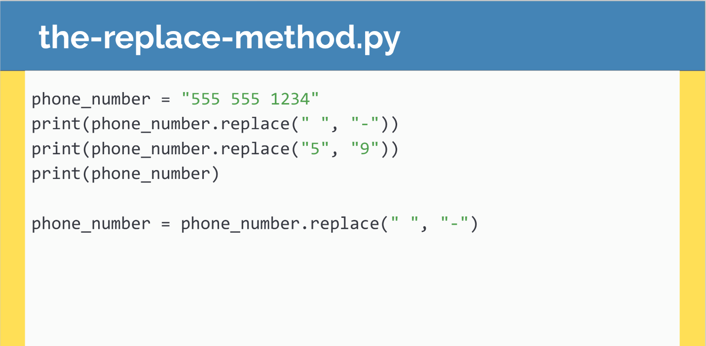

Resources for this lecture:
Learn to Code with Python - Course Notes.pdf

